Idea: Parking finder across SG

Features:

Search by (1) Location, (2) Rates, (3) Type of car park, (4) Availability, (5) Carpark height

Display rates for different days/times (eg. weekends/PH have higher rates)

User account (for ease of finding frequently visited locations)

Functional Requirements:

1. The driver must be able to sign up for an account
   1. The driver must input their name
   2. The driver must input their phone number
   3. The driver must input their email address
   4. The driver must set a secure account password
   5. Users must be able to reset their passwords.
   6. Users can save specific carparks to their account for quick access.
2. The system must allow the driver to search for carparks/query the system
   1. The driver must be able to search by location
   2. The driver must be able to search by parking rates
   3. The driver must be able to search by carpark type
   4. The driver must be able to search by lot availability
   5. The driver must be able to search by carpark height
3. The system displays carparks within 2km proximity of the desired location
4. The system must be able to display information of the selected carpark
   1. The system must display the carpark’s location
   2. The system must display the carpark’s rates
   3. The system must display the carpark’s type
   4. The system must display the carpark’s lots availability
   5. The system must display the carpark’s height
   6. The system must calculate the estimated parking cost using the user’s duration input
5. The system must display real time information of the carparks from the system
   1. The system must display parking lot availability in real time
   2. The system must display the current location of the driver in real time
   3. The system must be able to generate nearby available parking lots if chosen lot is full

Non-functional Requirements:

1. Performance & Reliability
   1. The system must load within 3 seconds under normal network conditions.
   2. The system must handle at least 1,000 concurrent users without performance degradation.
2. Usability
   1. The system must have a simple and intuitive UI for users of all ages.
   2. The system must support multiple languages (e.g. English, Chinese, Malay)
3. Security
   1. User data must be encrypted for storage.
   2. Passwords must meet certain requirements (e.g. must be 10 characters long, must have one number)
4. Compatibility
   1. The system must run on iOS (12 and above) and Android (8 and above).
   2. The system must work on major browsers (e.g. Chrome, Safari, Edge)

Data dictionary:

| **Term** | **Definition** |
| --- | --- |
| Driver | A person operating a vehicle |
| Vehicle | A mode of transport (e.g., car, motorcycle, van) |
| Carpark | A place where drivers may temporarily park their vehicles |
| Parking lot | A slot where one vehicle may be parked |
| Carpark location | The specific geographic coordinates or address of a parking facility |
| Carpark rate | The fee charged for parking, which may be based on time, day, or special conditions (e.g., season pass). |
| Carpark type | The classification of a carpark based on its ownership or accessibility, such as HDB, shopping mall etc. |
| Carpark availability | The real-time status of vacant parking spaces in a given carpark |
| Carpark height | The maximum allowable vehicle height for entry into a parking facility |
| HDB Carpark | A parking facility managed by Singapore's Housing & Development Board (HDB), typically serving residential estates and public areas |
| JTC Carpark | A parking facility managed by JTC Corporation, mainly serving industrial estates, business parks, and commercial developments in Singapore |

Initial Use Case Model:

Actors:

* Driver
* Navigation System

1. Use case diagram:

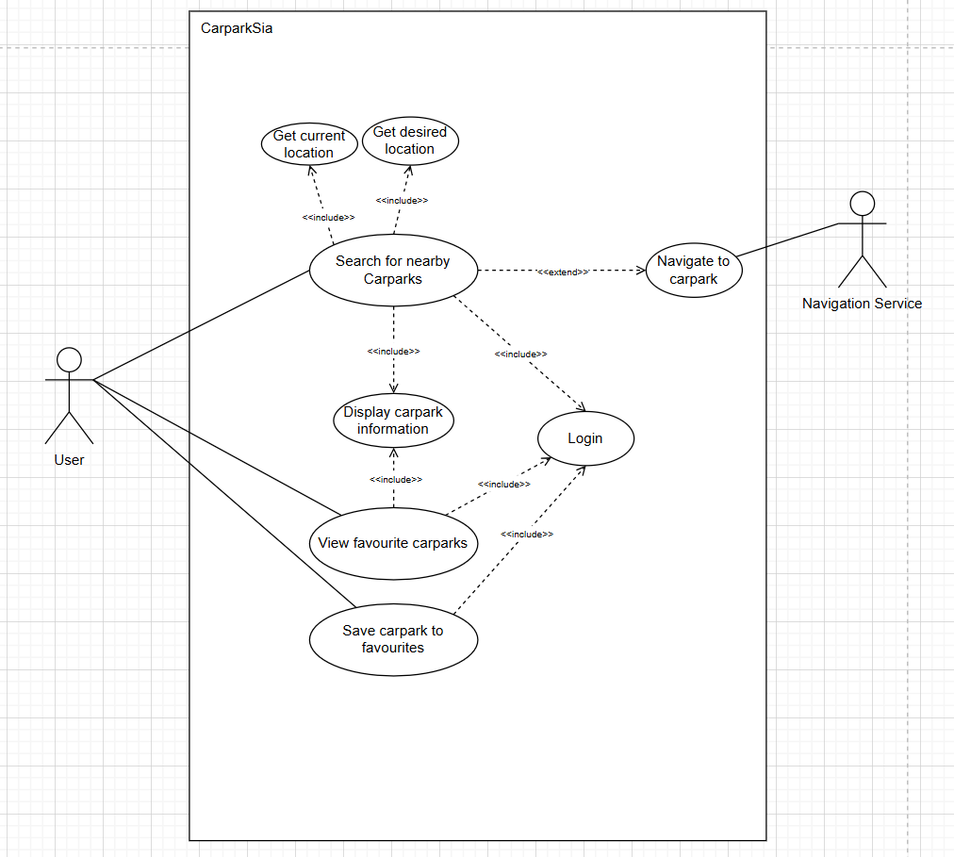

1. Use case description:
   1. Case 1: User wants to find available carparks near them
      1. Entry Conditions
         1. User must be logged in
         2. User must have location services available on their device, and give permission to the system to access them.
      2. Flow of events
         1. User initiates a search for nearby carparks by selecting "Find Carparks Near Me."
         2. The system requests the user's current location from the device's GPS.
         3. The system retrieves carpark data based on the user's location, including availability of parking lots, parking rates, carpark type, carpark height etc.
         4. The system displays a list of nearby carparks on a map or in a list view.
         5. User selects a carpark from the list to view detailed information.
         6. The system displays carpark details (i.e. availability of parking lots, parking rates, carpark type, carpark height)
         7. User may choose to navigate to the carpark by selecting "Get Directions."
         8. The system redirects the user to a navigation service (Google Maps).
         9. Use case ends when the user either selects a carpark or exits the search.
      3. Exit Conditions
         1. The user successfully finds a carpark and chooses to navigate there.
         2. The user exits the search without selecting a carpark.
      4. Alternative Flows (AF)
         1. AF-S2: System cannot retrieve users’ current location
            1. System displays the message “Cannot find your current location, please enable location services” until user clicks “OK”
            2. System returns to step 1
         2. AF-S8: Device does not have a navigation service installed
            1. System displays the message “Cannot direct you to a navigation service” until user clicks “OK”
            2. System returns to step 6
   2. Case 2: User Searches for a Carpark by Availability
      1. Entry Conditions:
         1. The user must be logged in
      2. Flow of Events
         1. The user selects "Search by Availability."
         2. The system retrieves carparks with available lots within the user’s selected range near the user’s location.
         3. The system retrieves carpark data based on the user's location, including availability of parking lots, parking rates, carpark type, carpark height etc.
         4. The system displays a list of nearby carparks on a map or in a list view.
         5. The user selects a carpark to view details.
         6. The system displays carpark details (i.e. availability of parking lots, parking rates, carpark type, carpark height)
         7. The user can navigate to the carpark or search again.
         8. The use case ends when the user selects a carpark to navigate to or exits the search.
      3. Exit Conditions
         1. The user finds a carpark with available lots and chooses to navigate there.
         2. The user exits the search without selecting a carpark.
      4. Alternative Flows
         1. AF-S5: No available lots at nearby carparks
            1. The system displays "No available lots nearby." until user clicks “OK”
   3. Case 3: User registers for an account
      1. Entry Conditions
         1. The user must not already have an account.
      2. Flow of Events:
         1. The user selects “Sign Up” on the login page.
         2. The system prompts the user to enter:
            1. Name
            2. Phone number
            3. Email address
            4. Password
         3. User enters their information and clicks confirm to verify that their information is accurate.
         4. The system validates the information:
            1. Ensures all fields are filled
            2. Checks password strength (based on certain requirements)
         5. The system saves their information into its database
         6. The user can now log in and use the system.
      3. Exit Conditions
         1. The user successfully creates an account and it is successfully saved into the database.
         2. The user cancels registration or exits before completing it.
      4. Alternative Flows
         1. AF-S5: Email already registered
            1. The system displays "Email already in use. Please log in or reset your password." until user clicks “OK”
         2. AF-S4: Weak password (min. 10 char, special characters, upper/lower case)
            1. The system displays the message “Password is too weak” until user clicks “OK”
            2. Return to step 2
   4. Case 4: User saves a favorite carpark
      1. Entry Conditions:
         1. The user must be logged in.
      2. Flow of Events:
         1. The user selects a carpark from the search results.
         2. The user clicks the "Save to Favorites" button.
         3. The system saves the carpark to the user’s account.
         4. The user can now access saved carparks from the "Favorites" section and view their real-time information.
      3. Exit Conditions:
         1. The carpark is successfully saved to the user’s account.
         2. The user cancels the action or exits the app.
      4. Alternative Flows:
         1. AF-S10: Carpark already in favorites

The system displays "This carpark is already in your favorites." until user clicks “OK”

UI mockup:

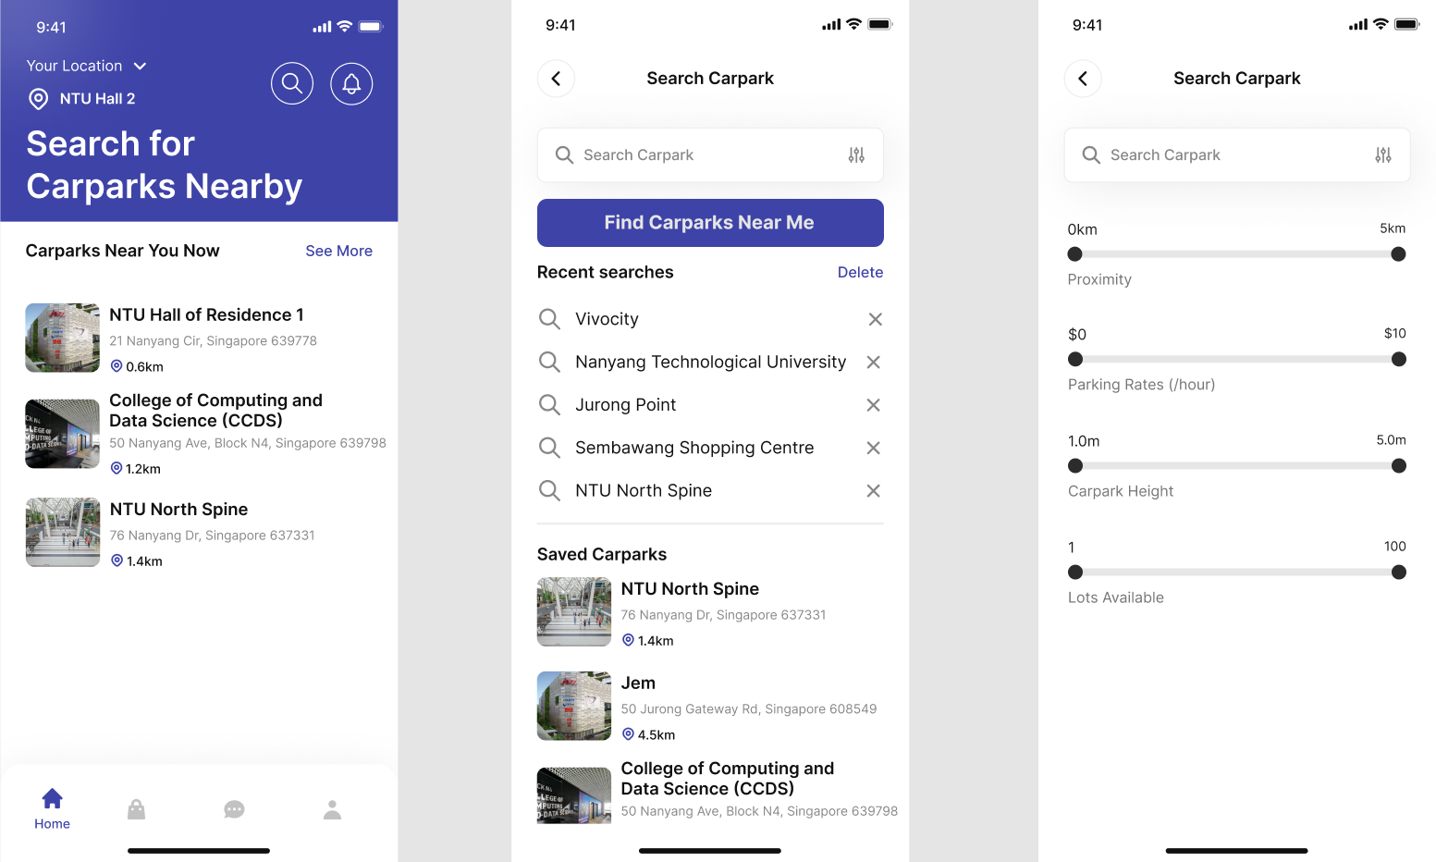

Filter: 2-way sliders → users can specify range of values that they are looking for